Standard Genetic Code
drawn by Michael Dixon, 2008
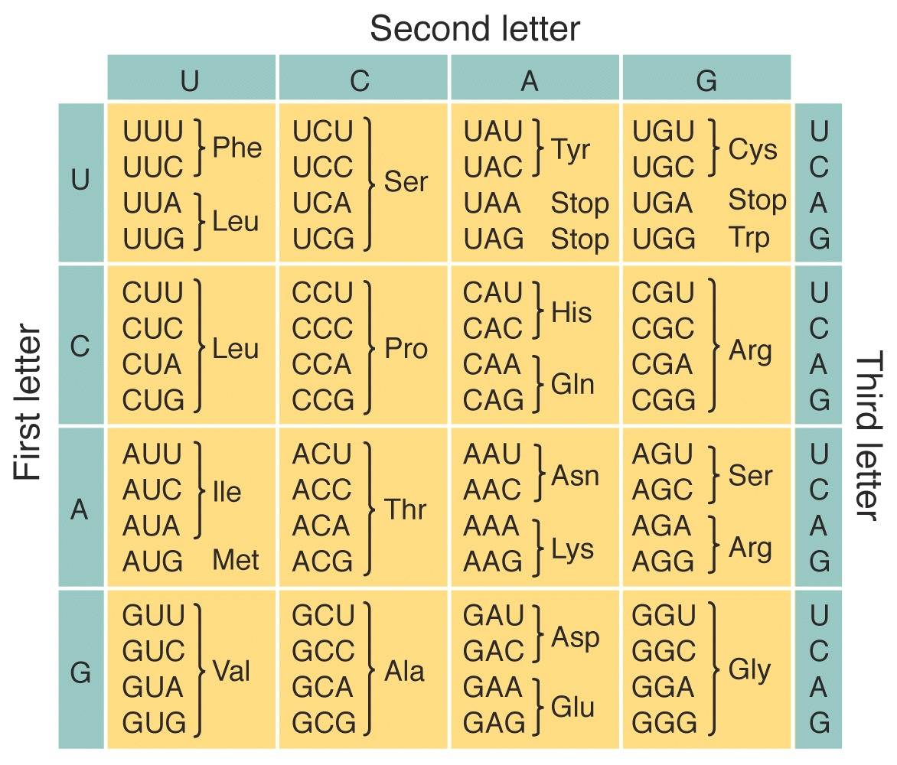

This table shows all 64 RNA codons of the genetic code that is used by most cells* to translate mRNA into proteins. The three-letter abbreviation for the amino acids is shown. This code is redundant as there is more than one codon for most of the amino acids (Met and Trp are the exceptions).

The table is set up so that the first base of the codon is on the left, the second base is on top and the third is on the right. For example the codon AAA is one of two codons for Lysine (Lys).

*A few organisms use a slightly different code as does the mitochondrion.

