PCR Protocol Supplies for Forensic PCR
Materials needed per class (assumes 4 student per group, 7-8 groups per class)
8 groups x 5 PCRs/group = 40 PCR reactions. Make 50 PCR reactions/class for safety.

If you make your own master mix and primer mix: Use 25 µL master mix, 15 µL primer mix and 10 µL DNA in each reaction. Each PCR reaction volume is 50 µL.

Make a master mix for 300 samples (should be plenty for 6 classes) as follows:
1.5 ml 10X Reaction Buffer
300 ul 10mM dNTPs
900 ul 50mM MgCl2
75 ul Taq Polymerase
4.8 mL sterile DH2O
Aliquote mix into 6-12 tubes

Make a primer mix for 300 samples (should be plenty for 6 classes) of the two primers:
300 ul 10uM pUC19 Left Primer
300 ul 10uM pUC19 Right Primer
3.9 ml H2O
Aliquot mix into 6 to 12 tubes

If you purchase pre-made master mix, it comes in 2x concentration. Use 25 µL master mix, 15 µL primer mix and 10 µL DNA in each reaction. Each PCR reaction volume is 50 µL.

Aliquot 2X master mix, 1 mL or 0.5 mL in each of 6 to 12 tubes

Make a primer mix for 300 samples (should be plenty for 6 classes)
300 µL of 10 µM pUC19 Left Primer
300 µL of 10 µM pUC19 Right Primer
4.5 mL sterile distilled H2O
Aliquot mix into 6 to 12 tubes.

To prep PCR forensics DNA samples add the following:
Make final concentration of pUC19 DNA to be 0.1pg/µL (.1 ng/mL)
+ control: 100 µL DNA
-control: 100 µL distilled water
Food 1: 100 µL distilled water
Food 2: 100 µL DNA
Food 3: 100 µL distilled water
NOTE: You can create any desired pattern of contamination

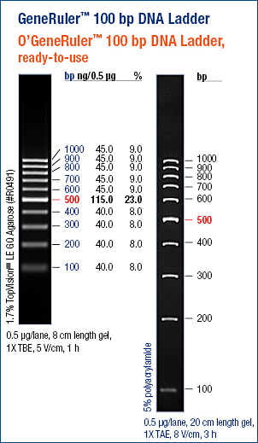
For each PCR, add the following in a 0.2 ml PCR tube:
25 ul Master Mix
15 ul Primer Mix
10 ul DNA sample (0.1 pg/ul pUC19 or H2O)

Thermal cycler conditions:
94°C 3 minutes
94°C 30 seconds
65°C 30 seconds x 35 cycles
72°C 30 seconds
72°C 7 minutes
4°C °

The pUC19 product is 511 bp.

Supplies per class (enough for 10 lab groups)
50 sterile PCR tubes, 10 of each color
10 PCR tube racks
10 ice buckets
10 sharpies
Gloves
Eye protection
p-20 micropipets (number depends upon lab setup)
p-200 micropipets (number depends upon lab setup)
2 0.5 mL tubes Master mix (if using stations. If set up in individual kits, 10 50µL tubes)
2 0.5 mL tubes PCR mix (if using stations. If set up in individual kits, 10 50µL tubes)
1 0.2 mL tubes + control DNA (if using stations. If individual kits, 10 20µL tubes)
1 0.2 mL tubes - control DNA (if using stations. If individual kits, 10 20µL tubes)
1 0.2 mL tubes Sample 1 DNA (if using stations. If individual kits, 10 20µL tubes)
1 0.2 mL tubes Sample2 DNA (if using stations. If individual kits, 10 20µL tubes)
1 0.2 mL tubes Sample3 DNA (if using stations. If individual kits, 10 20µL tubes)
PCR machine
PCR machine grid
10 electrophoresis kits (power supply, gel tray, gel box, comb, loading dye)
1 tube 100 bp ladder (if teacher pipets the ladder. If not, one tube per lab kit)
DNA Stain (ethidium or Carolina blue or other)
Gel camera (suitable for the type of DNA stain used)

